
a
Company
Logotype

Cone Beam Computed Tomography- Report



Porur Dental X-rays & CBCT

Patient Name : Miss. Sushmitha | Date of Report : 19.07.2024
Age/ Gender : 22 years/ Female | Region of Interest : CBCT Full Skull
Referring doctor: Dr. S. M. M. Moulvi | Indication : Malocclusion
Clinical Notes: Nil
PATIENT INFORMATION

CBCT- Full Skull provided
CBCT – IMAGE DETAILS

RADIOGRAPHIC INTERPRETATION

- No of teeth present in the maxillary and mandibular arch: 31, Missing teeth: 28.
- Horizontally impacted teeth: 18, 38; Mesioangular: 48.
- The maxillary and mandibular alveolar ridge are present with normal trabecular pattern.
- In relation to the periapical aspect of 46, presence of a diffuse, irregular hyperdense region is evident, that is located in contact with the apical third of 46.
- Presence of a similar diffuse area of hyperdensity in the 35, 36 region that is dispersed in the surrounding area is present.
- Presence of mild area of hypodensity in relation to the periapical aspect of 36 is also evident.

RADIOGRAPHIC IMPRESSION

- Impacted: 18, 38, 48
- Idiopathic osteosclerosis- right and left mandibular region.

Kindly correlate with clinical findings


IMAGES FOR REFERENCE

RECONSTRUCTED PANORAMIC VIEW
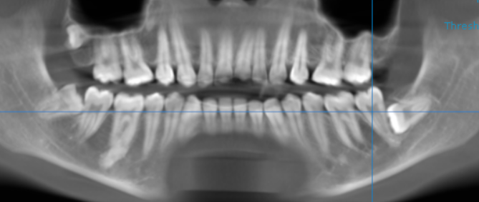

3-DIMENSIONAL VIEW

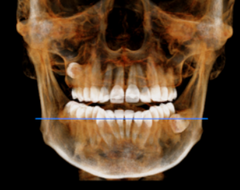

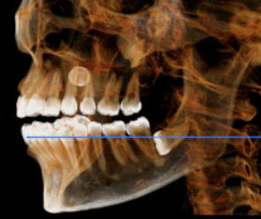
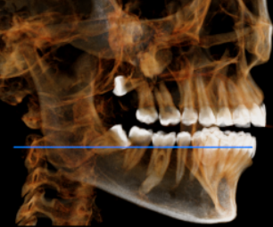

CROSS-SECTIONAL VIEW

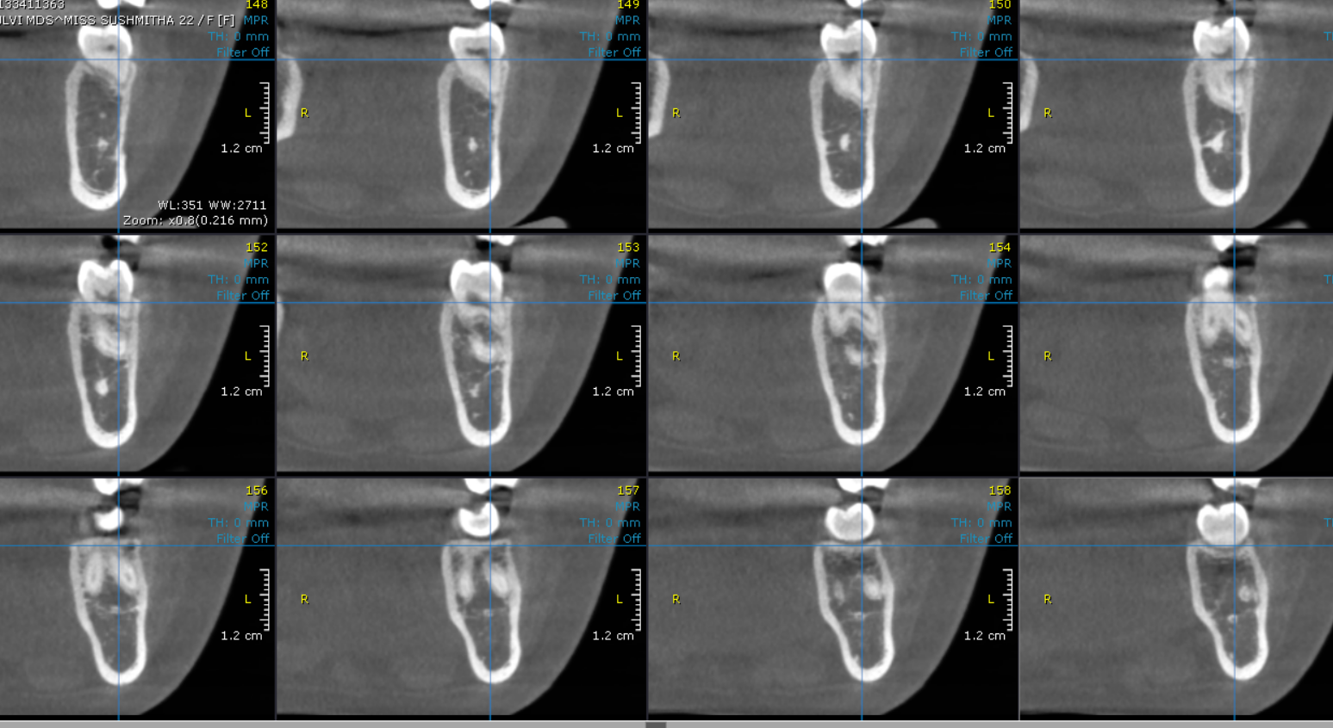

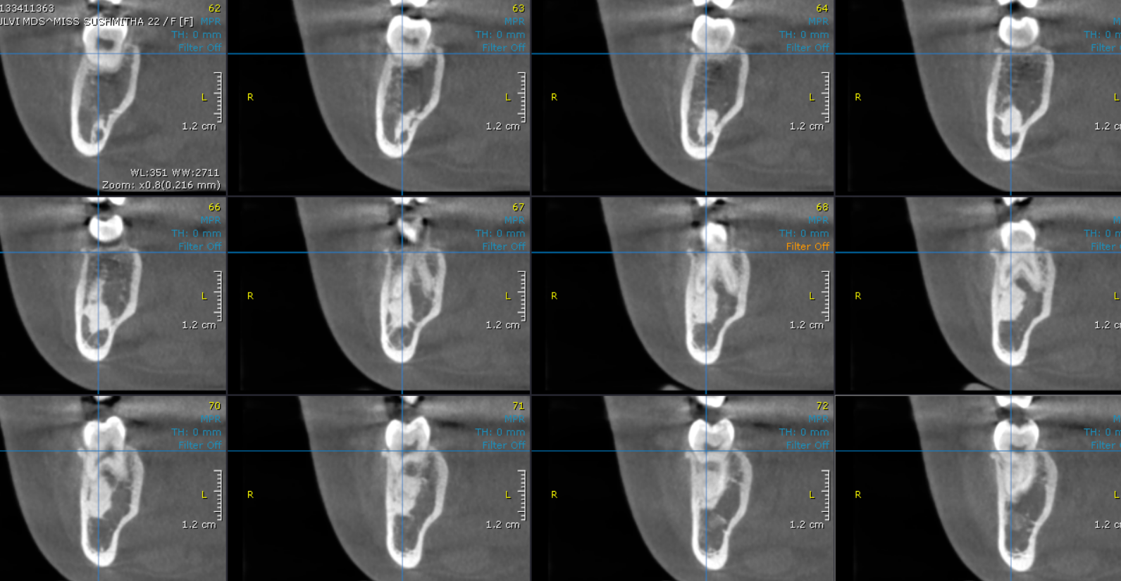

**** End of report ****

